FEBRUARY NEWSLETTER
Greetings: At Holy Name Catholic School, we live our faith by serving as good friends. Friendship is truly a blessing. Everyone needs a friend; Jesus is always a friend we can count on. Faith-filled actions that demonstrate friendship include: respecting the ideas of others, being helpful, including others, and showing care and support.
Dear Lord,
You fill us with your love.
With your help we will send this love
Out into the world,
Making the whole world
A kinder, more loving place for all creation.
Amen.
God Bless, Mrs. McDonald

Caring and Safe Schools:
This month, School Mass is scheduled at Holy Name Church on - Feb. 12th at 9:30 AM. Please join us.

Pink Shirt Day: Wed. Feb. 27, 2019 is recognized by the Boys and Girls Club as Pink Shirt Day. Students and staff are encouraged to show their support by wearing pink that day. The Boys and Girls Club programs foster self-esteem, social engagement, academic success, inclusion, acceptance, respect for self and others and connection to community – all of which are key elements of bullying prevention.
Promoting Positive School Climate and Well-being – Gr. 4 and Gr. 7 students participated in the Middle Years Development Instrument. The survey is to understand more about children’s thoughts, feelings and experiences inside and outside of school.
Family Literacy: There were several events to celebrate Family Literacy Day. Thanks to Mrs. Selkirk, Mrs. Irwin, and the Gr. 3-8 student committee members for all the planning and organizing. Dr. Seuss Day was a lot of fun and a lot of spirit was evident!

Knights of Columbus provided a Free Throw Competition on Fri. Jan. 18th which served as a great warm up to upcoming Board’s Basketball Tournaments, later this month.
Full-day Kindergarten Registration Registrations for the fall of 2019 are being accepted now. To register, the following documents are required: the child’s birth certificate, baptismal certificate, and record of immunization. Registration packages can be picked up at the school’s Main Office or parents can use the electronic registration link on our school webpage. Information about the full day Kindergarten program can be found at the Ministry of Education’s website at onatrio.ca/Kindergarten. As well, check out the following ALCSB video: https://www.youtube.com/watch?v=mK2vvTQYNuY&t=3s
Need your High School Diploma? Looking to get into College?
Loyola School of Adult and Continuing Education offers many options to support you in achieving your goals including high school credit courses, an accredited Personal Support Worker program and English as a Second Language classes. If you are over 18 years old and ready to take the next step in achieving your future, visit our website for more information: www.learningatloyola.ca

We encourage all families to follow us on Twitter: @alcdsb_name.
Provincial Report Cards for K-8 students will go home on Wed. Feb. 20th, following the Family Day holiday on Mon. Feb. 18, 2019. Interviews will follow at the request of the teacher and/or parent.
Basketball Tournaments: The Senior Boys Tournament is scheduled for Wed. Feb. 20, 2019. The Senior Girls Team is scheduled to play on Thurs. Feb. 21, 2019. The Junior Boys are scheduled to play on Mon. Feb. 25th and the Junior Girls on Tues. Feb. 26th. All details can be found on the Athletic link on the ALCDSB’s website. Many thanks to the Coaches: Mr. Archer, Mr. Waller, Mr. Gaudet and Mrs. Graham.
Catholic School Council Update

The Chili Cook-Off Fundraiser was a fun and successful winter event!
Special Guest Judges were: ALCDSB’s Chair of Trustees, Terry Shea, ALCDSB’s Chair of Finance, Michael Murphy and area Councillor, Gary Oosterhof. Mr. Gaudet’s Gr. 3/4 class won “People Choice”. Mr. Gaudet’s class also won “Meatiest”. Hayden and Miss Ross won “Fire in the Hole” (spiciest). Mrs. Graham and Class won “Best Decorated” table. Mrs. Mackler’s Gr. 2/3 class won “Not your Mama’s Chili” (unique/ unusual chili). The Wood Family won “There’ll Beano Relief” (best use of beans)! Over $600 was raised for the Playground Renewal Project. Thank you to all who came out and supported the family fun event.
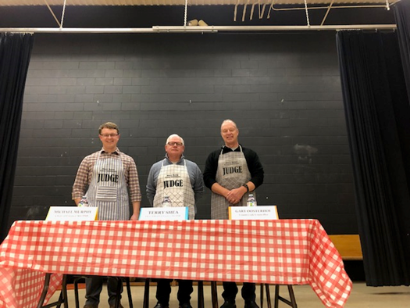
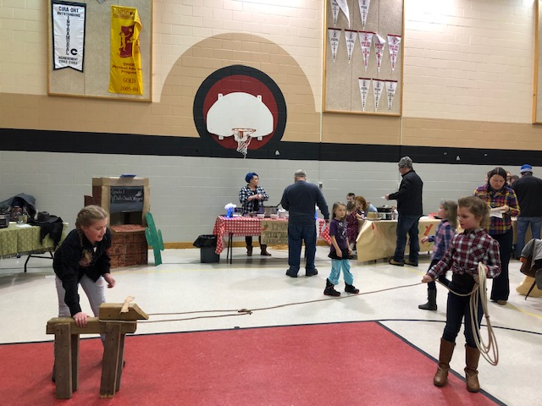
Minutes from meetings are posted on the school website once they are available from Council.
All parents are invited and encouraged to join the next Catholic School Council meeting on Feb. 27, 2019 @ 6:30 PM.

